**HUMBER INSTITUTE OF TECHNOLOGY**

**AND ADVANCED LEARNING**

**(HUMBER COLLEGE)**

**TEAM 6**

**CASE STUDY #2**

**Submitted by:**  **Grade/Comments**

|  |  |
| --- | --- |
| **Student Name** | **Student Number** |
| Anmol Narang | N01579763 |
| Divya Kuriakose | N01579609 |
| Joaquin Duran Barrero | N01578770 |
| Sagar Kapoor | N01537155 |
| Thi Loan To | N01578971 |
| Maleek Ottun | N01002842 |

**Submitted to:** Haytham Qushtom

**Submission Date:** August 06, 2024

1. **Introduction**

In this case study, we helped a pet rescue organization handle information on donations gathered annually. Creating a structured SQL database, building a dimensional model to examine data, and employing SQL stored procedures to address certain business concerns using SQL are the primary objectives. We aim to offer practical ideas to enable organizations to maximize their donations.

1. **Data Description**

**Sources**: We will use six CSV files, each one reflecting the collecting area of a different volunteer among our six team members: Sagar, Joaquin, Loan, Divya, Anmol, and Maleek. These records include thorough details on donors, donation amounts, and the volunteers that gathered them. Appropriately handling and evaluating donations depends on the information gathered in these files. The data is structured into three main categories:

* **Address**: unit_num, street_number, street_name, street_type, street_direction, postal_code, city, province
* **Volunteer**: first_name, last_name, group_leader
* **Donation**: donor_first_name, donor_last_name, donation_date, donation_amount, payment_method

1. **Database Creation**

We established a schema and generated the following SQL Server administration Studio (SSMS) tables to help data administration and analysis:

**Address**

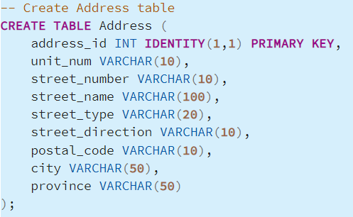

**Volunteer**

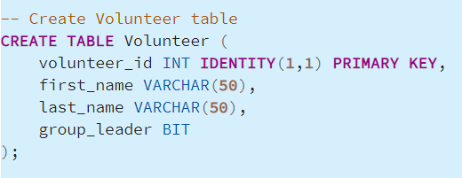

**Donation**

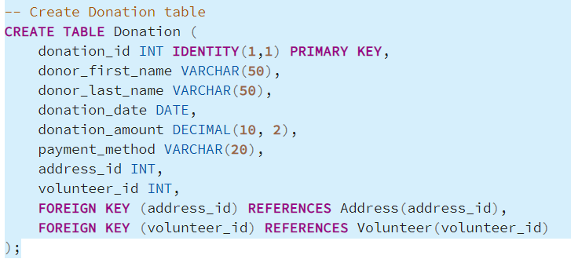

1. **Data Import and Integration**

Data Import: The BULK INSERT command loaded six CSV files' worth of data into the staging table.

Data Intergration: We cleaned and loaded the data into the final tables following data imports into the staging table.

1. **Dimensional Modeling**

***Dimensional Model Description:***

In data warehouses, dimensional modelling is a design idea applied to organize data in a way that maximizes query performance and is user-friendly. Among the easiest and most often used forms of dimensional models are star diagrams. It comprises a centre fact table around by dimension tables.

***The Star Schema:***

In data warehouses, dimensional modelling is a design idea applied to organize data in a way that maximizes query performance and is user-friendly. Among the easiest and most often used forms of dimensional models are star diagrams. It comprises a centre fact table around by dimension tables.

For our case study, we arranged the pet rescue charity's donations data using a star schema. There are these tables in this schema:

Fact Table: Donation

Dimension Tables: Address, Volunteer

*Fact Table: Donation*

The fact table has the numbers and measurements that can be used to describe the business activities. The Donation table is the fact table in this case. As a gift is made, it is recorded and linked to the address of the donor and the volunteer who received the donation.

*Dimension Table: Address*

Detail information regarding the donor's address is maintained in the Address table. In order to prevent redundancy and facilitate reference in the donations table, each address is recorded only once in this table.

*Dimension Table: Volunteer*

The Volunteer table contains information regarding the volunteers who collected the donations. Recognizing the contributions of group leaders and monitoring which volunteer collected which donations are facilitated by this table.

1. **Business Questions and Analysis**

We created SQL stored procedures to address the following business inquiries:

1. *What is the daily, monthly, and annual average and total of donations?*

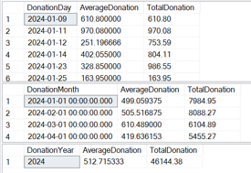

* Trends Over Time: The donation data shows a strong start at the beginning of the year, with total donations peaking in January and February. The average donation size increased in March but saw a decrease in total contributions.

1. *What is the monthly average and total of donations by city and postal code?*

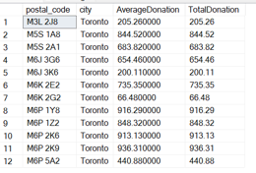

1. *What is the total amount received for each mode of payment for the city that received the largest donation?*



1. **Conclusions**